 | Parish of  Our Lady and St Alphege, Bath  together with  St Joseph’s, Peasedown St John  Parish Priest: Father Alex McAllister SDS  The Presbytery, Oldfield Lane, Bath BA2 3NR  01225 424894 / 07788 415200  bath.stalphege@cliftondiocese.com  www.saintalphege.org.uk  Parish Secretary: Alice Fouad Office: Behind Parish Hall | 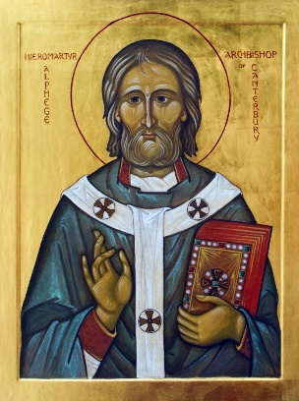
The Baptism of the Lord 8th January 2023
This is my Son, the Beloved

Mass Times at St Alphege
or St Joseph’s, Peasedown if indicated
Sat 7th Saturday after the Epiphany
10.00
Sun 8th Baptism of the Lord
9.00 (Peasedown)
11.00 Anne Creevy
18.00 Sheila McKee
Mon 9th Feria
10.00 Father Michael English
Tue 10th Feria
10.00 Canon John McAllister +
11.00 (Peasedown)
Wed 11th Feria
No Mass
Thu 12th Feria
No Mass
Fri 13th Feria
12.00 Mary Foulds +
Sat 14th Feria
10.00
Sun 15th Second Sunday in Ordinary Time
9.00 (Peasedown)
11.00 Nell Pestel +
18.00 Frances Russell +
Sunday Coffee
Coffee is served in the Parish Hall after 11.00 Sunday mass
Confessions Saturday 10.30 and at Call
Choir Practice 19.00 Wednesdays in Hall
Psalter Week 1
Sunday Readings: Year A
Weekday Readings: Year 1
Baptisms & Marriages: Contact the Parish Priest
Mothers Prayer Group Tuesdays 9.00-9:45 Term Time
Diocesan Prayer League SS George & Teresa, Taunton
& St John Fisher, Wellington
Cycle of Prayer: Ordinary Time: Advent/Christmas
Openness to the Word of God, Migrants and Refugees, Expectant Mothers
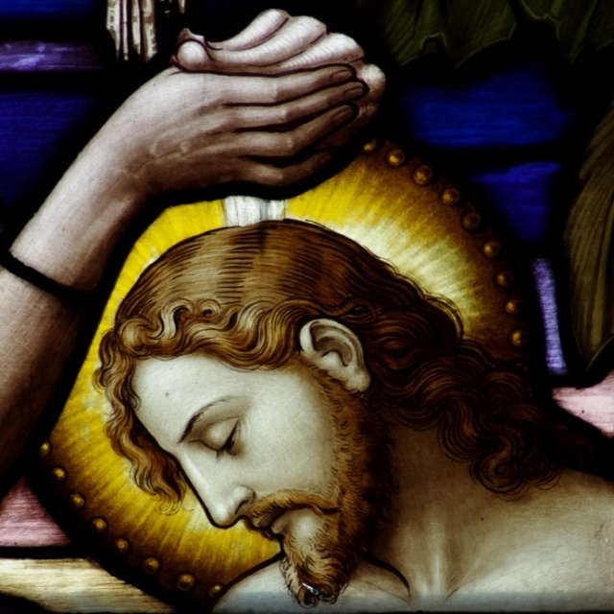
The Baptism of the Lord
Christ’s Baptism in the Jordan
Jesus’ public life begins with his baptism by John in the River Jordan. This gospel text is rich in meaning for us. John preaches a baptism of repentance for the forgiveness of sins. As we know, when Jesus presents himself for Baptism John hesitates and tries to dissuade him. But Christ insists on being baptised. This baptism of Jesus is his formal acceptance and inauguration of his mission to bring salvation to the people.
He allows his humanity to show through and although he has not sinned himself, he permits himself to be numbered among sinners. Although he is already the Lamb of God who takes away the sin of the world, he is submitting himself entirely to his Father’s will by consenting to this baptism which will lead to his death on the cross for the remission of our sins.
From heaven the Father proclaims his entire delight in him. Although Jesus is already at one with the Spirit he comes to rest on him at the moment of his Baptism. The word Christ comes from the Greek translation of the Hebrew ‘Messiah’ which means ‘anointed’. This baptism in the Jordan is also highly symbolic as the moment when, through being anointed with the Spirit, Jesus is revealed as the Messiah and the Holy One of God. It is one of the occasions when we see most clearly Christ’s divinity and humanity together. We remember that through our own baptism we are cleansed of our sins and can really believe in Christ as the Messiah who comes to save us.
Father Alex
First Communion
We will be beginning classes for our First Communion candidates on 22nd January 2023 directly after Sunday Mass. Please fill in a form available at the back of the Church and return to Father Alex. Candidates should be in Year 3 or above. The First Communion Mass itself will take place on Sunday 14th May 2023.
Everything comes from love,
all is ordained for the salvation of man, God does nothing without this goal in mind
St Catherine of Siena
SVP Film Night
We hope you have had a lovely Christmas. The SVP are hosting a film night with soup and pizza on Friday 20th January. We will be showing the film ‘Paddington’ at 18.30 and the hall will be open for food from 17:45.
All are welcome but please do put your name on the sign-up sheet at the back of the Church for us to know how many we are catering for. Thank you and we look forward to seeing you.
Converting to Catholicism
In the New Year Father Alex will be starting classes for those wishing to become Catholics. These classes will lead up to reception into the Church at Easter. If you are interested, please speak to him so that a suitable time can be arranged.
Feast of Our Lady of Lourdes
The Sacrament of the Sick will be offered here at St Alphege’s on Saturday 11th February at the 10.00 mass to celebrate the Feast of Our Lady of Lourdes which is also World Day of Prayer for the Sick.
The Beacons
Thank you so much to all of you who came to our Christmas community gathering. You raised over £100 for the SVP and it was a great atmosphere. Please come and join us for our New Year celebration on Monday 16th January. We will be raising money for the Bath branch of the British Heart Foundation and welcoming the new year in with a glass of wine as well as nibbles and cake.
Father Alex is Away this Week
Father Alex is away this week from 11th to 18th January. Please note that there will be no mass on Thursday this week and Monday and Thursday next week.
If you want your dreams to come true,
you mustn't oversleep
Forthcoming Dates
Beacons 16th January
SVP Film Night 20th January
First Communion Classes start 22nd January
Talk on St Thomas More 27th January
Sacrament of the Sick 11th February
Ash Wednesday 22nd February
Easter Sunday 9th April
St Thomas More
Dr Giles Mercer will be giving a talk entitled ‘Why was St Thomas More Executed?’ in the Parish Hall at 19.00 on Friday 27th January. Refreshments before and after. He recently gave this talk to Winchester Catholic History Society where it was very well received.
Sunday Coffee
More volunteers are needed to help prepare the tea and coffee after 11.00 Sunday mass. Please let Father Alex know if you can help.
Little Church
Little Church resumes this Sunday 8th January.
A Prayer for the Baptism of the Lord
Open the heavens, almighty Father,
and pour out your Spirit
upon your people gathered in prayer.
Renew the power of our baptismal cleansing
and fill us with zeal for good deeds.
Let us hear your voice once again,
that we may recognise in your beloved Son
our hope of inheriting eternal life.
Grant this through Jesus Christ,
your Word made flesh, who lives and reigns with you
in the unity of the Holy Spirit,
in the splendour of eternal light,
God for ever and ever. Amen.
ICEL
Faith is to believe what we do not see;
and the reward of faith is
to see what we believe.
St. Augustine
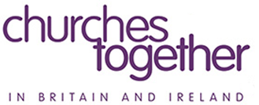
The Week of Prayer for Christian Unity takes place from 18th to 25th January 2022. It always concludes with the feast of the Conversion of St Paul. Materials are available at: ctbi.org.uk/week-of-prayer-for-christian-unity-2023.
Christmas Crib
All gifts at the Crib are given to the Clifton Children’s Society. Please support the important work of our adoption agency as generously as you can. The crib will remain in the Church until 2nd February, the Feast of the Purification.
Offertory Collection
1st January: Loose £295.89, Gift Aid Envelopes £71.00
Upcoming Second Collections
Today 8th January: Friends of the Holy Land, 22nd January: SPUC, 5th March CAFOD

