 | Parish of  Our Lady and St Alphege, Bath  together with  St Joseph’s, Peasedown St John  Parish Priest: Father Alex McAllister SDS  The Presbytery, Oldfield Lane, Bath BA2 3NR  01225 424894 / 07788 415200  bath.stalphege@cliftondiocese.com  www.saintalphege.org.uk  Hall Bookings: Isabella Lo (Parish email above) | 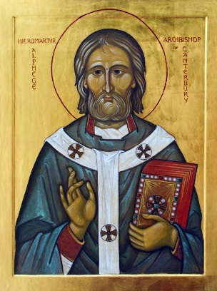
Twenty second Sunday in Ordinary Time 3rd September 2023
Get behind me Satan!

Mass Times at St Alphege
or St Joseph’s, Peasedown if indicated
Sat 2nd Feria
10.00
Sun 3rd Twenty second Sunday in Ordinary Time
9.00 Parishioners (Peasedown)
11.00
18.00 Holy Souls
Mon 4th St Cuthbert
10.00
Tue 5th Feria
10.00
11.00 (Peasedown)
Wed 6th Feria
No Mass
Thu 7th Feria
18.00
Fri 8th Nativity of the Blessed Virgin Mary
12.00
Sat 9th Feria
10.00
Sun 10th Twenty third Sunday in Ordinary Time
9.00 Parishioners (Peasedown)
11.00
18.00
Sunday Coffee
Coffee is served in the Parish Hall after 11.00 Sunday mass
Confessions Saturday 10.30 and at Call
Choir Practice 19.00 Wednesdays in Hall
Psalter 1
Sunday Readings: Year A
Weekday Readings: Year 1
Baptisms & Marriages: Contact the Parish Priest
Mothers Prayer Group Tuesdays 9.00-9:45 Term Time
Diocesan Prayer League Our Lady, Glastonbury;
St Michael, Shepton Mallet; Queen of Apostles, Cheddar; SS Joseph & Teresa, Wells
Cycle of Prayer: Ordinary Time Summer
A Deeper Understanding between Christians and Jews, Those who suffer Persecution, Oppression, and Denial of Human Rights, Europe, Human Life, Seafarers
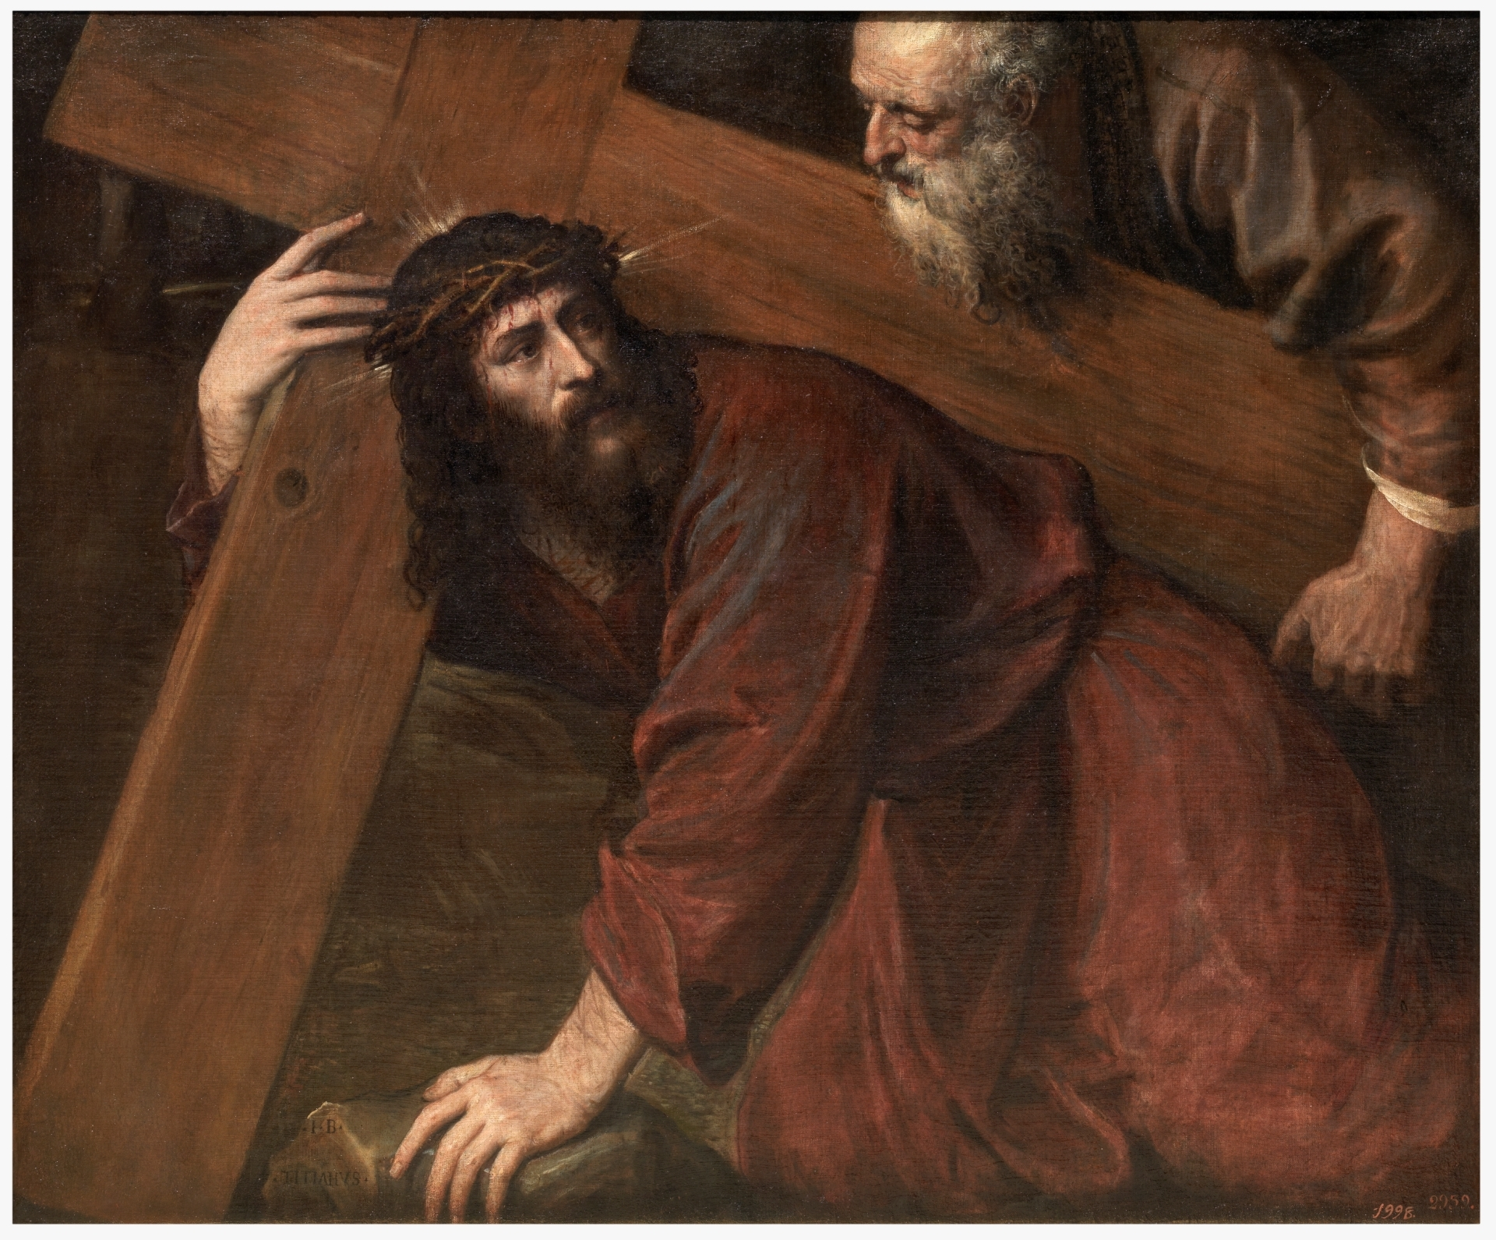
If anyone wants to be a follower of mine, let him renounce himself and take up his cross and follow me.
Jesus Christ, the Borrower
The people of the world have known, and still know, their need of a Saviour. When he comes, he comes as one in need.
He is born in a borrowed stable, and learns the trade of a borrowed father. He eats and sleeps in borrowed homes, preaches from borrowed boats, enters a capital city on a borrowed donkey.
He shares his last supper in a borrowed room. Betrayed for borrowed money he is aided with his Cross by a borrowed shoulder. He borrows a home for his mother, and is buried in a borrowed tomb. Risen and alive in power, he is still a borrower: He wishes to borrow you and me.
We will hold a Parish Quiz Evening on Friday 29th September at 19.00 in the Parish Hall. Teams are limited to five persons (two children count as one person) with twelve tables in total. Entry £3 per adult and £1.50 per child. Winner’s prizes: 1st £50, 2nd £25. Beer, wine and light refreshments available. Donations of raffle prizes most welcome. Please sign the list at the back of the Church to register your team. Come and test your wits and have a fun evening.
The only mistake in life
is the lesson not learned
Albert Einstein
Confirmation
The Deanery Confirmation Mass 2023 will take place on Friday 10th November, celebrated by Mgr Liam Slattery at St Mary’s Church, Bath. The preparation course for young people in Year 9-13 (under 19) will begin in September at St Mary’s, Julian Road, Bath. Please complete one of the forms at the back of the Church or email them at bath.stmary@cliftondiocese.com with the name of the young person and contact details.
Free Money for your Church!
Any member of the congregation who is a UK Taxpayer can Gift Aid their contribution and secure an additional 25% for the Church. This costs you nothing extra! The easiest way to do this is by setting up a standing order to pay directly into the St Alphege bank account. If you do not wish to set up a standing order, or commit to a regular weekly or monthly donation, then you can use the Gift Aid envelope system. Numbered Gift Aid envelopes can be put into the collection whenever you attend church, but do not have to contain the same amount, or be put in the collection, every week e.g. if you are away or on holiday etc. This gives you complete flexibility over the amount and timing of your donation. All donations are treated in strictest confidence. For the truly Ad Hoc donation there are envelopes at the back of the church which allow you to Gift Aid one off contributions. Please do use the Gift Aid system if you are eligible to do so – it really will bring in much needed income for the Church – for which we are very grateful. If you wish to pursue either of these options please contact Maureen Dyson, either via Fr Alex or by email at GA.bath.stalphege@cliftondiocese.com.
Don’t judge each day
by the harvest you reap
but by the seeds that you plant
Robert Louis Stevenson
Forthcoming Dates
Quiz 29th September
Diocesan Day 7th October
OT Talk Abraham 27th October
OT Talk Moses 17th November
OT Talk David 1st December
OT Talk Elijah 8th December
Autumn Talks
The two series of talks that we have held on Matthew in Autumn 2022 and on the Elizabethan Jesuits in Spring 2023 have both proved to be successful so we would like to continue with another four talks in the Autumn. This time the theme will be Important Figures from the Old Testament. A lot of Catholics don’t know too much about the Old Testament so this will be an opportunity for us all to become a bit more familiar with the Hebrew Scriptures. These are the dates, topics and speakers: 20th October, Abraham by Monsignor Jeremy Rigden; 17th November, Moses by Father Alex McAllister; 1st December, David by Anne Barrett and 8th December, Elijah by Dominic Bailey
Choir
We could do with a few new members of the Choir to enhance the singing at Sunday Masses. If you would like to join then please come along to rehearsals on Wednesday nights in the Hall at 19.00.
Going to University this Autumn?
Each University and Higher Education Institute in the country has a dedicated Catholic Chaplain based either in the University or in the local parish.
The Catholic Chaplaincy is a place for you to explore your faith, to meet people with similar interests from a great range of backgrounds, and to get involved in activities and social outreach.
If you already have a strong faith, this is a chance to deepen it. If you are full of questions and doubts, this is a chance to share them and search for some honest answers about life and faith. Everyone is welcome. For addresses see www.catholicsatuniversity.org.uk.
The Holy Scriptures were not given
to us that we should enclose them in books, but that we should engrave them
upon our hearts
St John Chrysostom
School Mass
The School Mass for the beginning of the new school year will be at 10.00 on Thursday 14th September.
Shona Mass
There will be a Mass for the Congolese people in the Shona language at 13.00 on Saturday 16th September.
Heritage Open Days
The Church will be participating once again in the annual Heritage Open Days. The Church will be open all day on Saturday 9th, Thursday 14th and Saturday 16th September. Dr Giles Mercer will give a guided tour of the Church at 14.30 on those days. All welcome. The Eyre Chapel at Perrymead Cemetery is also open 9th & 10th September from 11.00 to 16.00.
Upcoming Special Collections
Home Missions 17th September
Sunday Collection
Last week loose: £350.67, Gift Aid Envelopes £40
Readers
11.00: Relston n/w Veritas, 18.00; Moira n/w Duncan

