 | Parish of  Our Lady and St Alphege, Bath  together with  St Joseph’s, Peasedown St John  Parish Priest: Father Alex McAllister SDS  The Presbytery, Oldfield Lane, Bath BA2 3NR  01225 424894 / 07788 415200  bath.stalphege@cliftondiocese.com  www.saintalphege.org.uk | 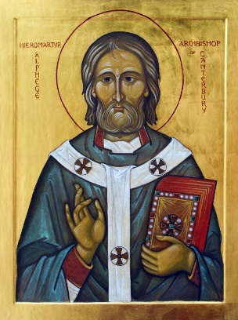
Easter Sunday 9th April 2023
He is risen!

Mass Times at St Alphege
or St Joseph’s, Peasedown if indicated
Sat 8th Holy Saturday
20.00
Sun 9th Easter Sunday
9.00 (Peasedown)
11.00
18.00
Mon 10th Monday within the Octave of Easter
10.00
Tue 11th Tuesday within the Octave of Easter
10.00
11.00
Wed 12th Wednesday within the Octave of Easter
No Mass
Thu 13th Thursday within the Octave of Easter
18.00
Fri 14th Friday within the Octave of Easter
12.00
Sat 15th Saturday within the Octave of Easter
10.00
Sun 16th Second Sunday of Easter
9.00 (Peasedown)
11.00
18.00
Sunday Coffee
Coffee is served in the Parish Hall after 11.00 Sunday mass
Confessions Saturday 10.30 and at Call
Choir Practice 19.00 Wednesdays in Hall
Psalter Proper
Sunday Readings: Year A
Weekday Readings: Year 1
Baptisms & Marriages: Contact the Parish Priest
Mothers Prayer Group Tuesdays 9.00-9:45 Term Time
Diocesan Prayer League St Alphege, Bath
& St Joseph, Peasedown
Cycle of Prayer: Easter
New Members of the Church, Vocations, Human Work, The Right Use of the Media, The Church
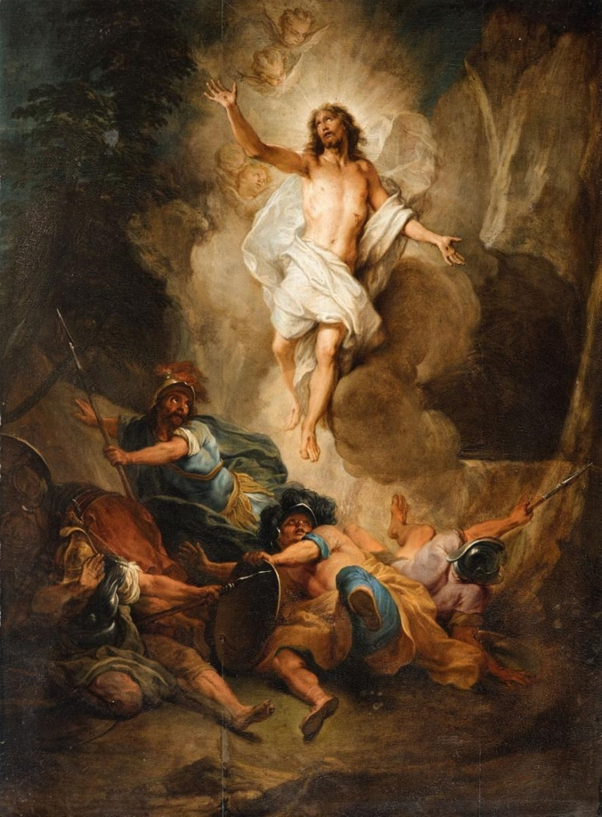
The Resurrection of Christ, Nicholas Bertin
Easter Sunday
Easter Sunday is the most important feast in the Liturgical Year because it celebrates the central Christian mystery of the resurrection. The Jews keep the Sabbath holy as they were instructed to in the Ten Commandments but we Christians keep Sundays holy because the first day of the week was the day of the resurrection.
It is especially important that we mark this day by going to Church but also by celebrating together as a family. Right across Europe families will be sitting down to an Easter lunch often involving lamb, reminding us that Jesus was the Lamb of God. The Jewish people ate lamb at the Passover as they were intructed to do by God and since the Last Supper was essentially a Passover meal we Christians continue to do this at Easter. Father Alex
Jesus Christ, the Borrower
The people of the world have known,
and still know, their need of a Saviour.
When he comes, he comes as one in need.
He is born in a borrowed stable,
and learns the trade of a borrowed father.
He eats and sleeps in borrowed homes,
preaches from borrowed boats,
enters a capital city on a borrowed donkey.
He shares his last supper in a borrowed room.
Betrayed for borrowed money
he is aided with his cross by a borrowed shoulder.
He borrows a home for his mother,
and is buried in a borrowed tomb.
Risen and alive in power, he is still a borrower:
He wishes to borrow you and me.
Be a saint
rather than be called one
St Bruno
Little Church
Volunteers urgently needed to lead Little Church. Ideally the parents of the children who attend should lead the sessions. Please let Father Alex know if you can help. We have not held Little Church for the last few weeks due to lack of helpers. It would be good if they could restart soon. It only needs a short liturgy, the Gospel, a brief discussion and a few prayers with some time to draw a picture.
Social Committee
There will be a meeting of the Social Committee in the Parish Hall on Friday 14th April. All welcome.
Coronation Garden Party
Our Coronation Garden Party will be held after Sunday Mass on Sunday 7th May. If you would like to bake cakes or help in any way please contact Emily 07886 396681 or Debbie 07804 900594
Eucharistic Ministers
We are looking for a few new Eucharistic Ministers who could bring communion to the housebound once a month. Please talk to Father Alex.
Easter Organ Concert
We are holding an Organ recital on Friday 21st April at 19.00. The organist is Shean Bowers and music includes ‘Occasional Oratorio’ by Handel, ‘Nun Danket Alle Gott’ by Bach, ‘O Fili et Filiae’ by Dandrieu and ‘An Easter Alleluia’ by Slater and several other works. Tickets £10 adults, £5 concessions. Refreshments in the Parish Hall afterwards.
When the well’s dry,
we know the worth of water
Benjamin Franklin
Forthcoming Dates
Social Committee 14th April
Organ Concert 21st April
Elizabethan Jesuits Talk 28th April
Elizabethan Jesuits Talk 5th May
Coronation Garden Party 7th May
Elizabethan Jesuits Talk 19th May
Readers Course 3rd June
Corpus Christi Procession, Prior Park 11th June
International Evening 16th June
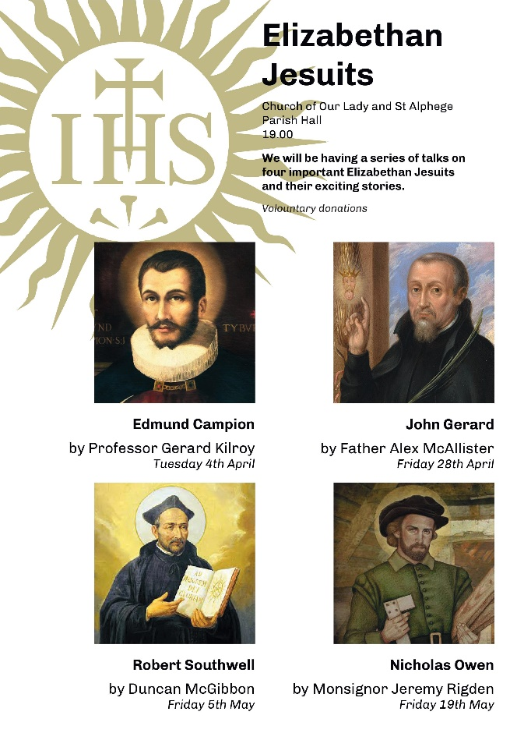
Missio
Please return your Missio red boxes to the sacristy for counting and pick up any old ones from the back of the Church. Please make sure they are correctly labelled. In total £1,069 was raised in the last year plus those who have direct debits with Missio. An excellent result! If you would like a Missio box please ask.
To one who has faith,
no explanation is necessary
To one without faith,
no explanation is possible
St Thomas Aquinas
Beacons
The next meeting of the Beacons is 24th of April with fund raising for ‘Ripple Effect’, previously known as ‘Send a Cow’, see poster in the Church porch.
Readers Course
We have organised a course for readers from all the parishes in Bath here at St Alphege on Saturday 3rd June from 11.00 to 15.00. Please bring a packed lunch.

We wish all our parishioners a very happy and blessed Easter
Upcoming Special Collections
23rd April Clifton Adoption Society, 7th May Clergy Training
Sunday Collection
2nd April Plate £387.78, Gift Aid Envelopes £42
Readers
11.00: Karen n/w Bibian, 18.00; 18.00 Dominic n/w Grainne

